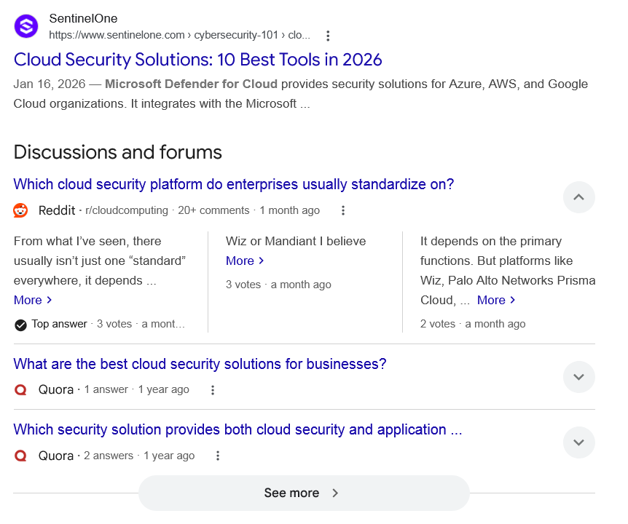
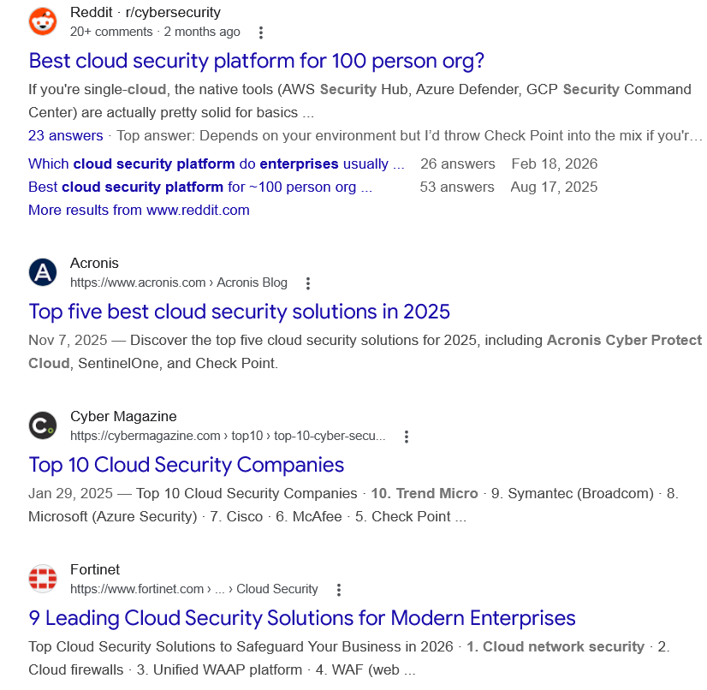
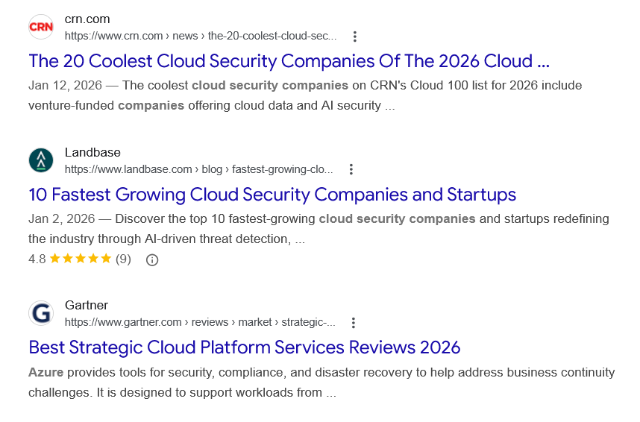
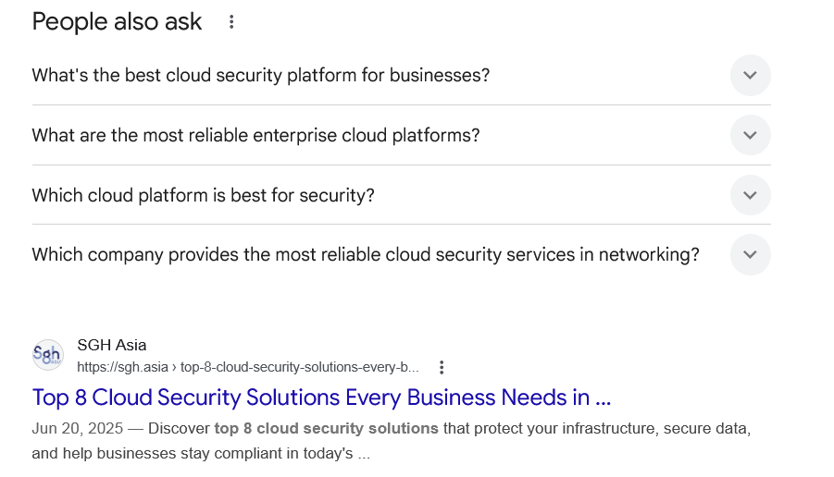
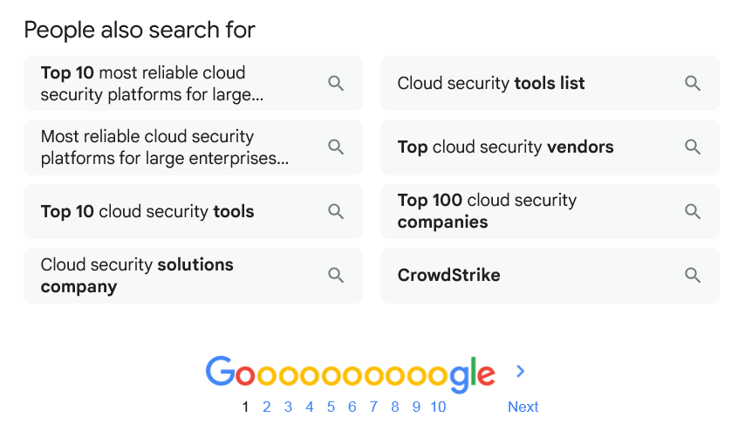

Web results

Cloud Security Solutions: 10 Best Tools in 2026

SentinelOne
https://www.sentinelone.com › cybersecurity-101 › clo...

SentinelOne
https://www.sentinelone.com › cybersecurity-101 › clo...
Jan 16, 2026 — Microsoft Defender for Cloud provides security solutions for Azure, AWS, and Google Cloud organizations. It integrates with the Microsoft ...
Discussions and forums

Which cloud security platform do enterprises usually standardize on?
Reddit ·
r/cloudcomputing
· 20+ comments
· 1 month ago

Which cloud security platform do enterprises usually standardize on?
Reddit ·
r/cloudcomputing
· 20+ comments
· 1 month ago
From what I’ve seen, there usually isn’t just one “standard” everywhere, it depends ... More
Top answer · 3 votes · a month ago
Wiz or Mandiant I believe More
3 votes · a month ago
It depends on the primary functions. But platforms like Wiz, Palo Alto Networks Prisma Cloud, ... More
2 votes · a month ago

What are the best cloud security solutions for businesses?
Quora ·
1 answer
· 1 year ago

What are the best cloud security solutions for businesses?
Quora ·
1 answer
· 1 year ago
Some of the top cloud security solutions for businesses include: CrowdStrike, Palo Alto Networks (Prisma Cloud), Fortinet, ... More

Which security solution provides both cloud security and application ...
Quora ·
2 answers
· 1 year ago

Which security solution provides both cloud security and application ...
Quora ·
2 answers
· 1 year ago
None that I can recall and I spend much of my work life investigating such technologies. If I did wander across such a solution I would immediately discard ... More
Top answer · 2 votes · a year ago

See more

Web results

Best cloud security platform for 100 person org?

Reddit · r/cybersecurity
20+ comments · 2 months ago

Reddit · r/cybersecurity
20+ comments · 2 months ago
If you're single-cloud, the native tools (AWS Security Hub, Azure Defender, GCP Security Command Center) are actually pretty solid for basics ...
23 answers · Top answer: Depends on your environment but I’d throw Check Point into the mix if you're still evaluating. ...
Which cloud security platform do enterprises usually ...
26 answers
Feb 18, 2026
Best cloud security platform for ~100 person org ...
53 answers
Aug 17, 2025
More results from www.reddit.com

Top five best cloud security solutions in 2025

Acronis
https://www.acronis.com › Acronis Blog

Acronis
https://www.acronis.com › Acronis Blog
Nov 7, 2025 — Discover the top five cloud security solutions for 2025, including Acronis Cyber Protect Cloud, SentinelOne, and Check Point.

Top 10 Cloud Security Companies

Cyber Magazine
https://cybermagazine.com › top10 › top-10-cyber-secu...

Cyber Magazine
https://cybermagazine.com › top10 › top-10-cyber-secu...
Jan 29, 2025 — Top 10 Cloud Security Companies · 10. Trend Micro · 9. Symantec (Broadcom) · 8. Microsoft (Azure Security) · 7. Cisco · 6. McAfee · 5. Check Point ...

9 Leading Cloud Security Solutions for Modern Enterprises

Fortinet
https://www.fortinet.com › ... › Cloud Security

Fortinet
https://www.fortinet.com › ... › Cloud Security
Top Cloud Security Solutions to Safeguard Your Business in 2026 · 1. Cloud network security · 2. Cloud firewalls · 3. Unified WAAP platform · 4. WAF (web ...

The 20 Coolest Cloud Security Companies Of The 2026 Cloud ...

crn.com
https://www.crn.com › news › the-20-coolest-cloud-sec...

crn.com
https://www.crn.com › news › the-20-coolest-cloud-sec...
Jan 12, 2026 — The coolest cloud security companies on CRN's Cloud 100 list for 2026 include venture-funded companies offering cloud data and AI security ...

10 Fastest Growing Cloud Security Companies and Startups

Landbase
https://www.landbase.com › blog › fastest-growing-clo...

Landbase
https://www.landbase.com › blog › fastest-growing-clo...
Jan 2, 2026 — Discover the top 10 fastest-growing cloud security companies and startups redefining the industry through AI-driven threat detection, ...
4.8(9)

Best Strategic Cloud Platform Services Reviews 2026

Gartner
https://www.gartner.com › reviews › market › strategic-...

Gartner
https://www.gartner.com › reviews › market › strategic-...
Azure provides tools for security, compliance, and disaster recovery to help address business continuity challenges. It is designed to support workloads from ...
People also ask
What's the best cloud security platform for businesses?
- Check Point CloudGuard Network Security. By Check Point Software Technologies. 4.6. ...
- Wiz CNAPP. By Wiz. ...
- Cortex Cloud. By Palo Alto Networks. ...
- CrowdStrike Falcon Cloud Security. By CrowdStrike. ...
- Sysdig Secure. By Sysdig. ...
- FortiCNAPP. By Fortinet. ...
- Trend Vision One Cloud Security. By Trend Micro. ...
- Singularity Cloud Security. By SentinelOne.
More items...

Cloud Security Posture Management Tools Reviews and Ratings - Gartner

Gartner
https://www.gartner.com › reviews › market › cloud-sec...

Gartner
https://www.gartner.com › reviews › market › cloud-sec...
What are the most reliable enterprise cloud platforms?
- Amazon Web Services. By Amazon Web Services (AWS) 4.6. (4598 Ratings) ...
- Microsoft Azure. By Microsoft. 4.5. (2247 Ratings) ...
- Google Cloud Platform. By Google. 4.6. ...
- IBM Cloud. By IBM. 4.5. ...
- Oracle Cloud Infrastructure. By Oracle. 4.3. ...
- Huawei Cloud. By Huawei. 4.7. ...
- Alibaba Cloud. By Alibaba Cloud. 4.3. ...
- Tencent Cloud. By Tencent Cloud. 4.6.
More items...

Best Strategic Cloud Platform Services Reviews 2026 - Gartner

Gartner
https://www.gartner.com › reviews › market › strategic-...

Gartner
https://www.gartner.com › reviews › market › strategic-...
Which cloud platform is best for security?
AWS is architected to be the most secure global cloud infrastructure on which to build, migrate, and manage applications and workloads. This is backed by the trust of our millions of customers, including the most security sensitive organizations like government, healthcare, and financial services.

Cloud Security – Amazon Web Services (AWS)

AWS
https://aws.amazon.com › security

AWS
https://aws.amazon.com › security
Which company provides the most reliable cloud security services in networking?
The Top 5 Cloud Security Providers
- #1. Check Point. Check Point from Check Point provides unified cloud security management, offering complete visibility across complex and dynamic cloud environments. ...
- #2. Singularity by SentinelOne. ...
- #3. Prisma Cloud by Palo Alto. ...
- #4. Falcon Cloud Security by CrowdStrike. ...
- #5. Zscaler.

The Top 5 Cloud Security Solutions - Check Point Software

Check Point
https://www.checkpoint.com › cyber-hub › tools-vendors

Check Point
https://www.checkpoint.com › cyber-hub › tools-vendors

Web results

Top 8 Cloud Security Solutions Every Business Needs in ...

SGH Asia
https://sgh.asia › top-8-cloud-security-solutions-every-b...

SGH Asia
https://sgh.asia › top-8-cloud-security-solutions-every-b...
Jun 20, 2025 — Discover top 8 cloud security solutions that protect your infrastructure, secure data, and help businesses stay compliant in today's ...
People also search for

Top 10 most reliable cloud security platforms for large enterprises

Most reliable cloud security platforms for large enterprises reddit

Top 10 cloud security tools

Cloud security solutions company

Cloud security tools list

Top cloud security vendors

Top 100 cloud security companies

CrowdStrike

Page navigation
 | 1 | 2 | 3 | 4 | 5 | 6 | 7 | 8 | 9 | 10 | Next

